# Methods

## Cart:

Our cart package

https://github.com/darryldecode/laravelshoppingcart

## Filter:

### 1-filter for a dress store:

First for any kinda filter we always have a form to submit our form have no action to load on curent page.

#### Front:

Episode:104-106

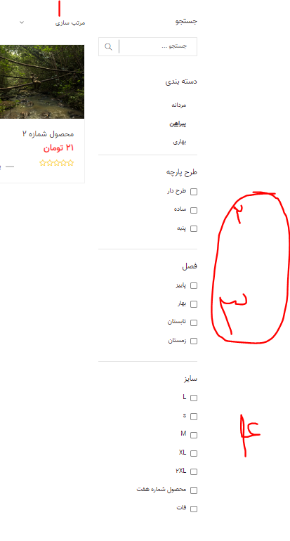

-In here we want by any changes on page a filter happen so we buld a js function and use onchange attribute event on tags to do the function:

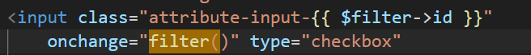

consider for any type of input what event we use

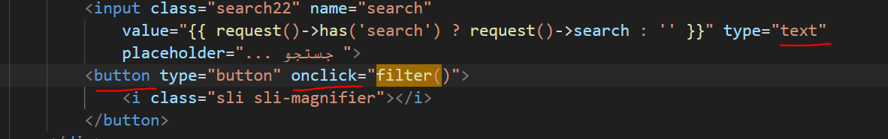

Socond: we need hidden inputs destinations,for having a good data face for working on ,in backend

Our desire input form:we have as many as want attribute so make it uniqe by attach id.



In asset there is filter directory for review how to do second part to check jquery codes.

#### Backend:

For rendering filter request we build a scop to be able to customise our query.remember the only good way to build a filter backend is with scope.

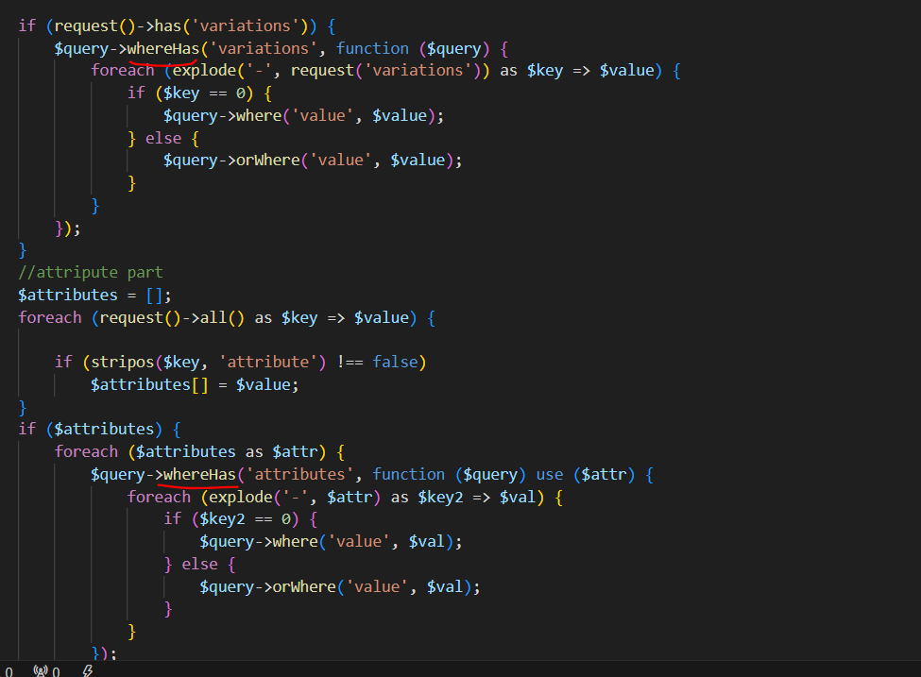

Relation that exists in product class

Logic-above:We have to use whereHas because in query we have a lot of products that are from a category so we are not face with one product to check its variation with where method we should use whereHas to directly put the where on target.

Clik for more about whereHas

-for sort base on price, as price is in another table we use bellow method:

Its kindalike whereHas because we actully need to evaluate another table that is in relation with us.

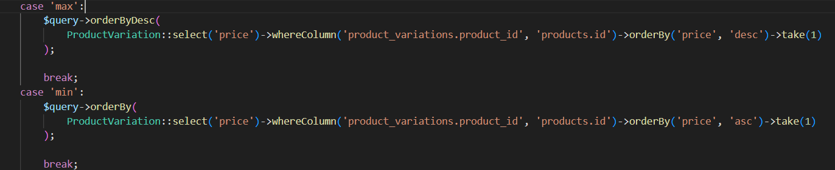

We only can use take

Above code only work on ordering products it has no power to filter and decrease count of products.

-scope codes are in assets.

## Codes that I get interested to:

Replacement of first()!

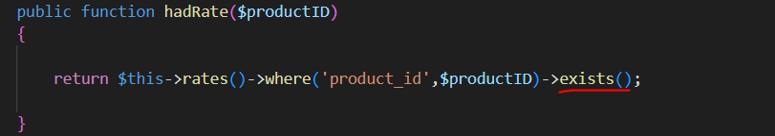

**pluck**



Find() can get an array to return.

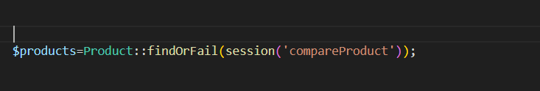

### Set costom redirect with parameters



### $loop:

I did not check but it seems only work on blade foreach

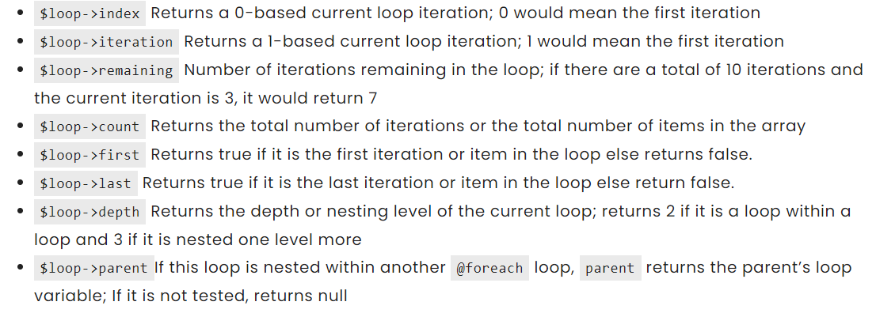

### How to add a php helper file to project?

After setting file in a directory in app directory define the file in composer.json:

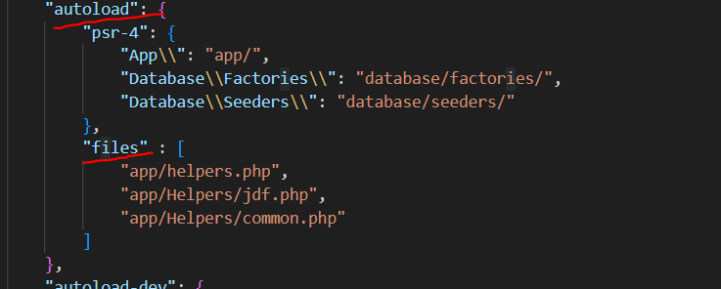

Now tell to composer do autoload again: composer dump

## Upload file

### Initials

1. Define a path in env file: 
2. We need a helper function to make the names unicqe,to attach time to file name:

use Carbon\Carbon;

if (!function_exists('generateFileName')) {

    function generateFileName($name)

    {

        $year = Carbon::now()->year;

        $month = Carbon::now()->month;

        $day = Carbon::now()->day;

        $hour = Carbon::now()->hour;

        $minute = Carbon::now()->minute;

        $second = Carbon::now()->second;

        $microsecond = Carbon::now()->microsecond;

        return $year . '_' . $month . '_' . $day . '_' . $hour . '_' . $minute . '_' . $second . '_' . $microsecond . '_' . $name;

    }

}

1. If we need to upload image in more than one time its beter to create a contrller to make it easer:

Click link to tutorial of object and controll tips.

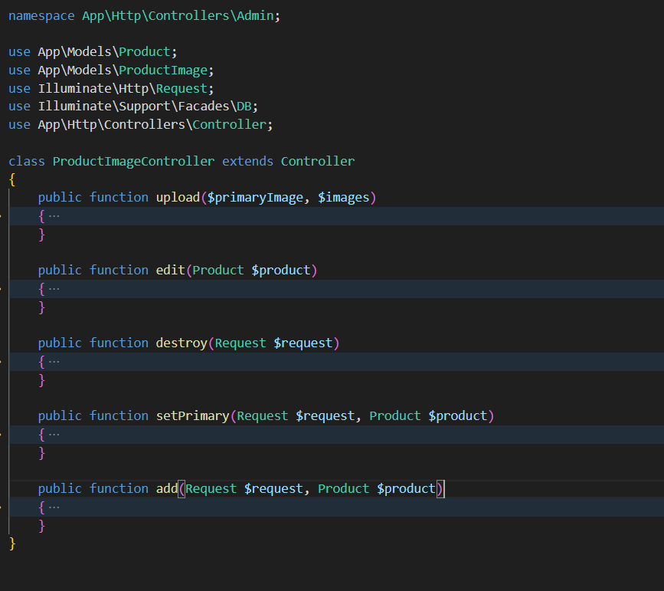

### Upload:

It only have three step first make a uniqe name second use move method and then uplaod file name on database:

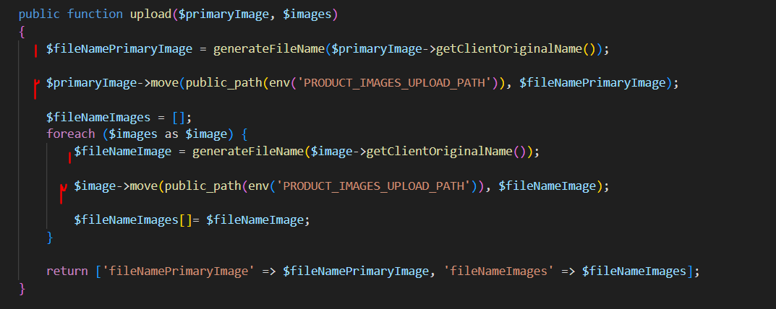

### Delete

Via classic php:

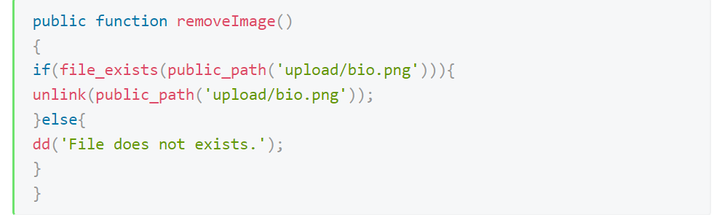

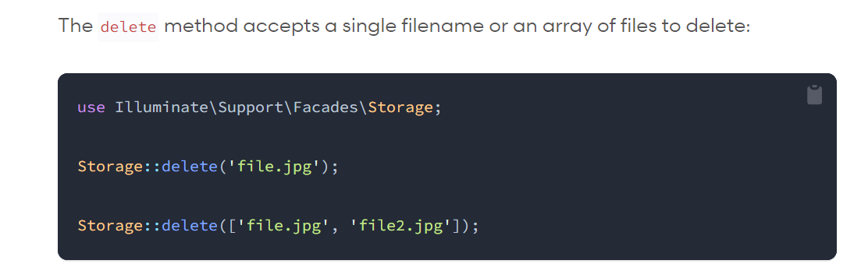

### Show



## Work with objects

### Use methods of a controller to another:

First we simply make a new object of our class,second we can use its method with our parameters:



There is a reference in this document

# DB

## Crud:

Insert:

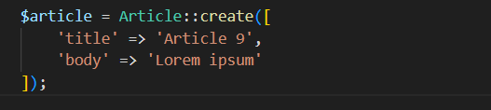

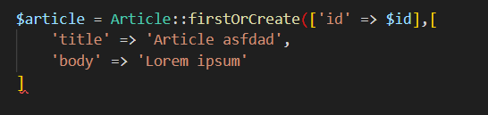

Select:

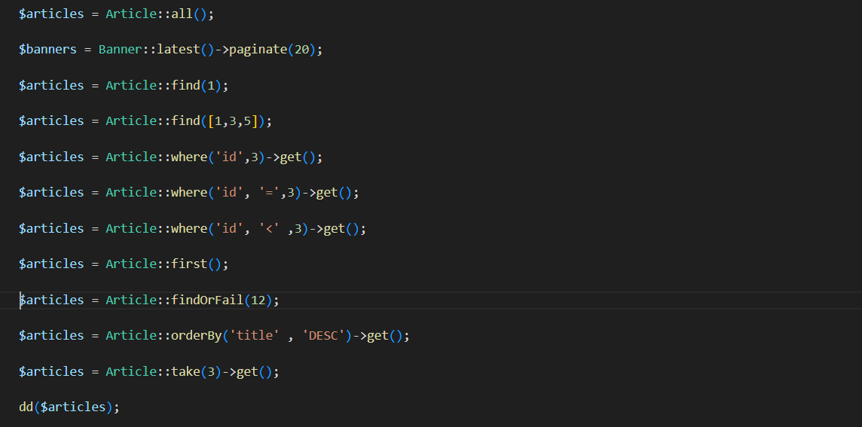

Update:

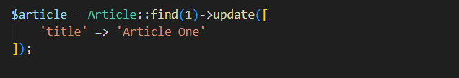

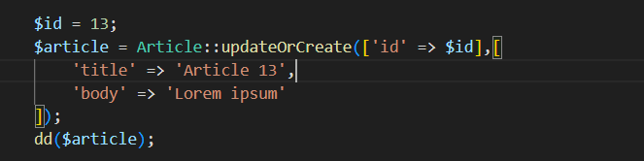

Delete:





DB transaction:

----------------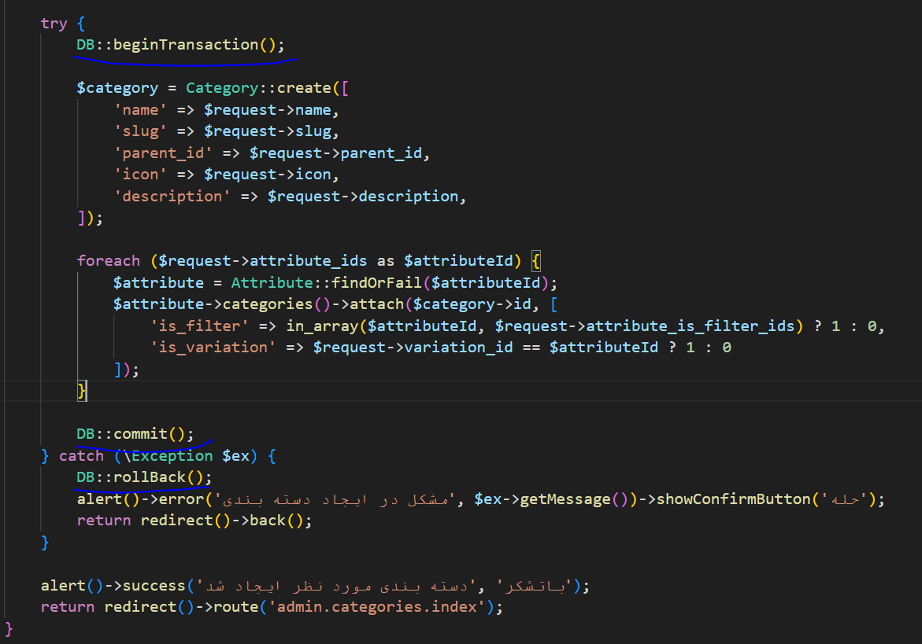

## Migration

#### initial

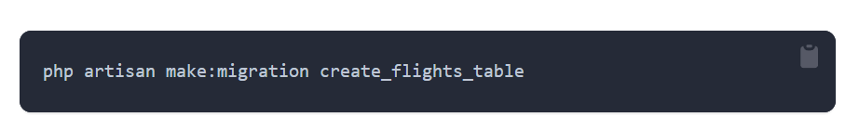

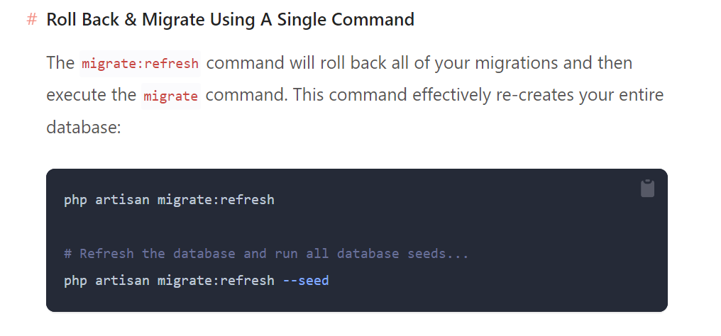

#### Schema tabel

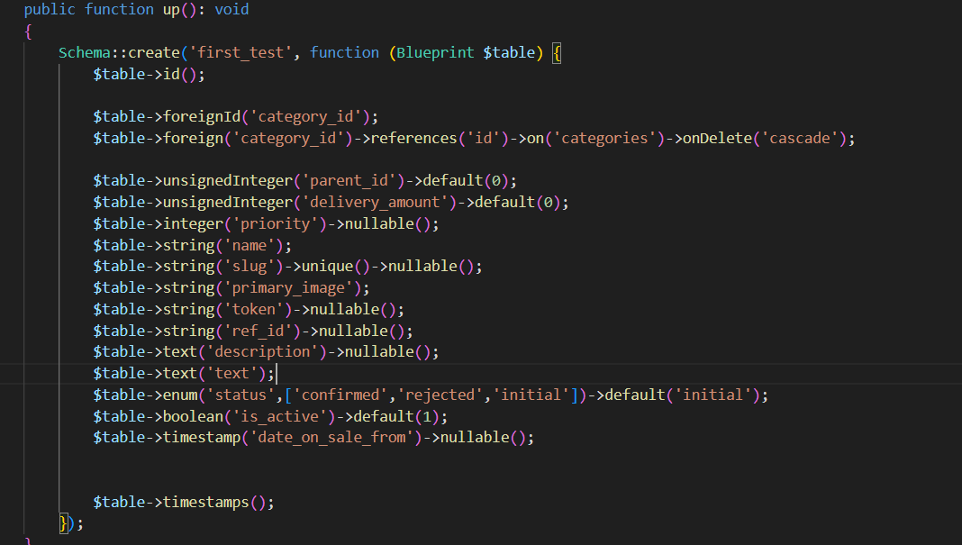

#### pivot table schema

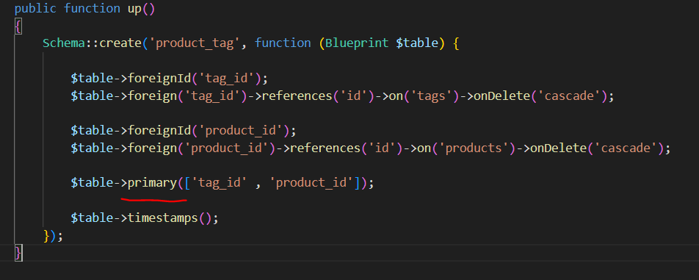

## Relations

**Note: every time we say belongs that mean in orgin(our object) there is a forigen key that belong to somewhere,**

**And in other way when we say origin has that mean its forigen key exsists in destination.**

#### One to one:

Relation between user and profile, 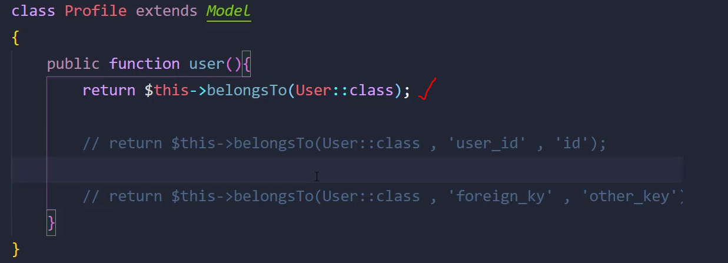

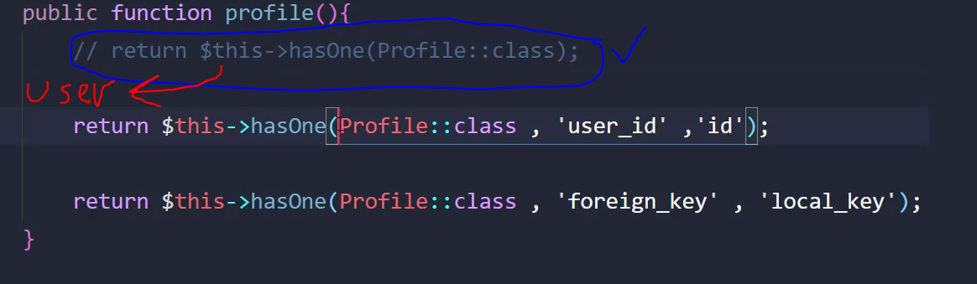

#### One to many:

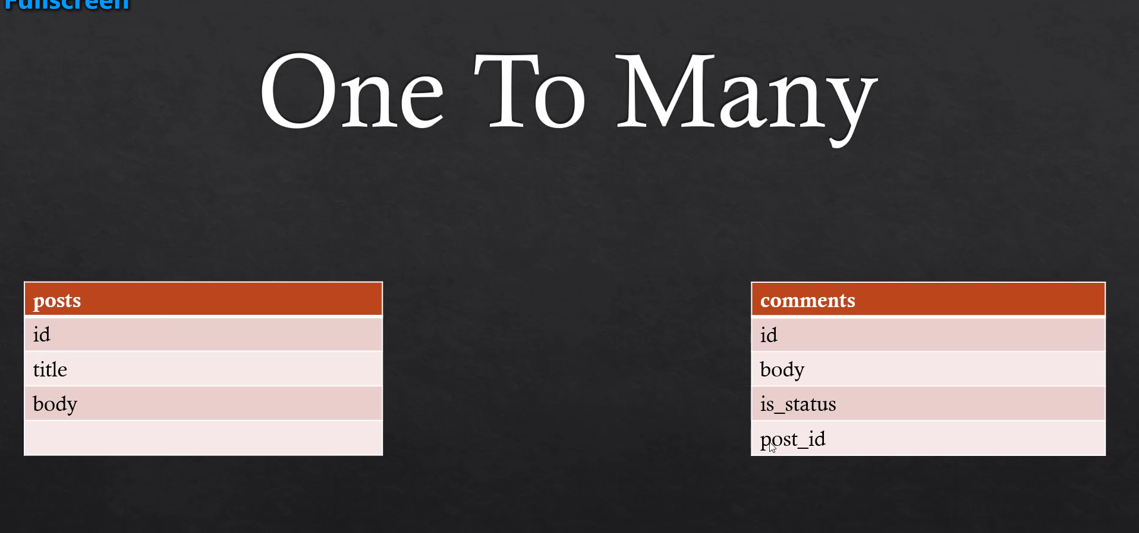

Any post has many comments,

Post foreign key is in comment so we can say

Post has in comment.

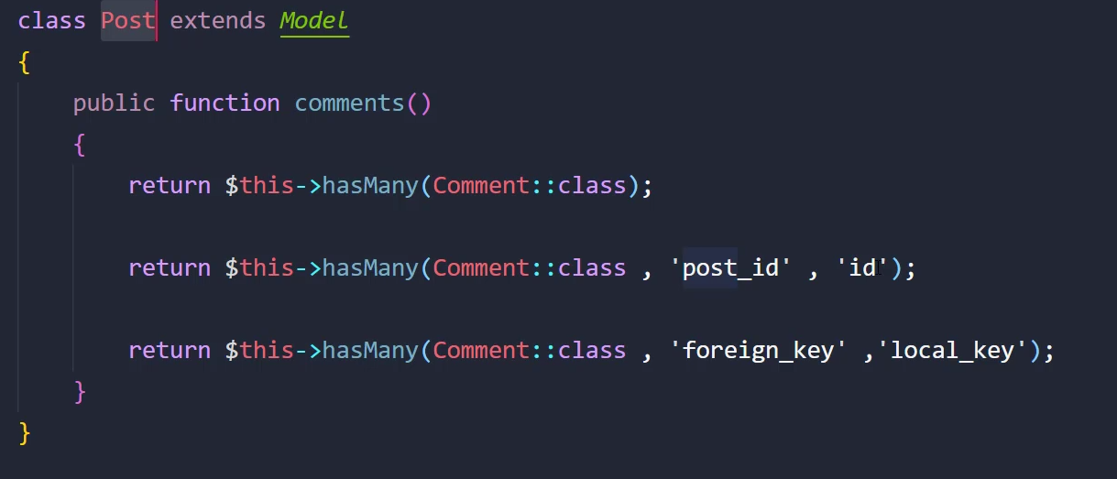

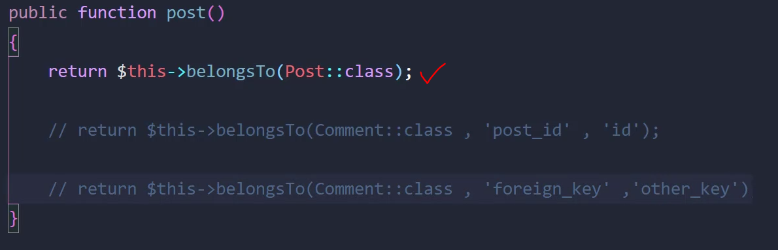

#### Many to many

Laravel standard:

1-words are selected in alpheba order

2-words are single

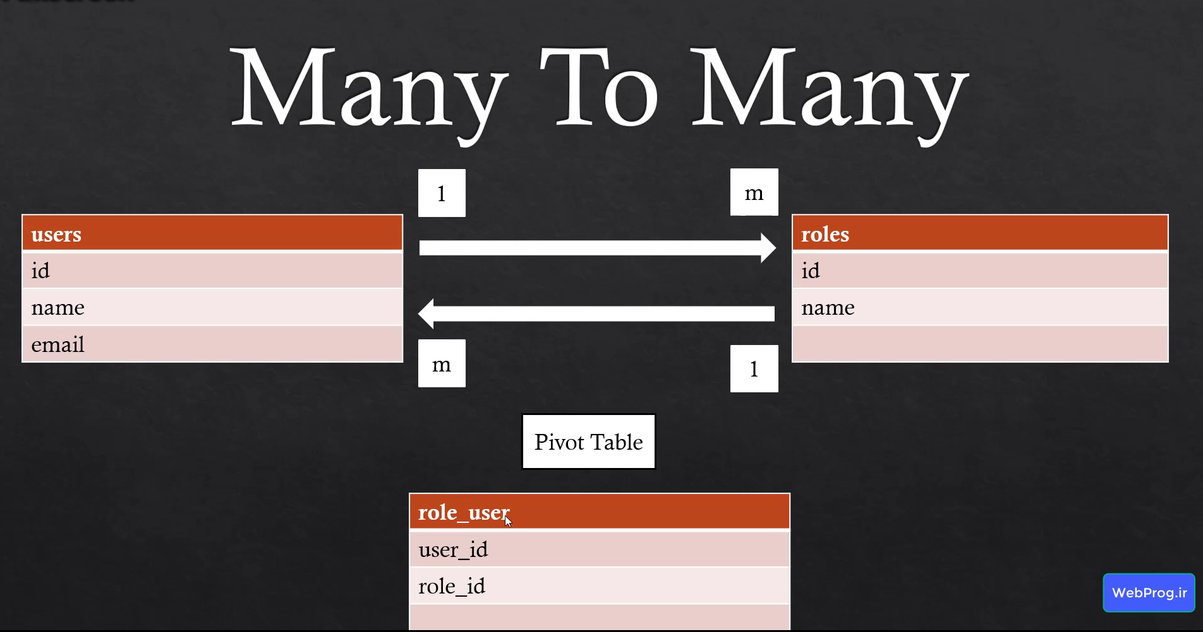

The folowing relation is equl in role and user mode

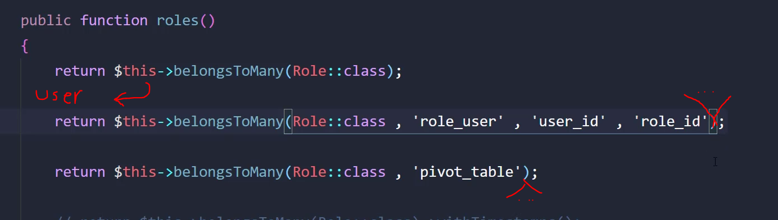

#### How to add to pivote tabel

As we don’t biuld role_user model(if we want we can have one) we can use the relation between to table to add to there pivote.

Save and attach are same ,and detach is obvious but sync is usefull because first it delete orgin rows(on below code any roles that belongs to user number 2) on pivot tabel then do attach that it fix malfuncton of duplicated rows.

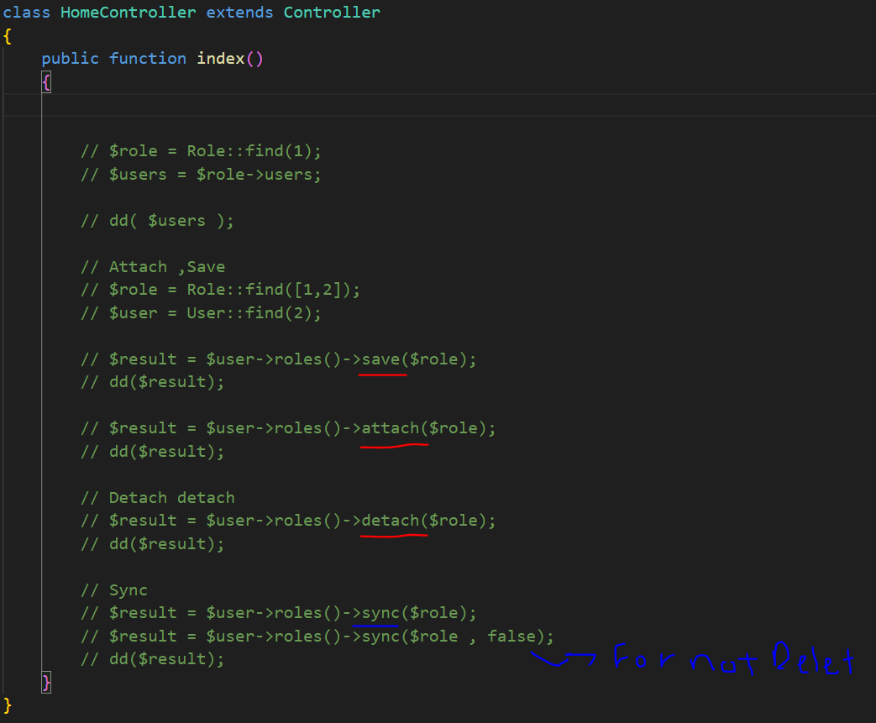

How to fill additional colums?

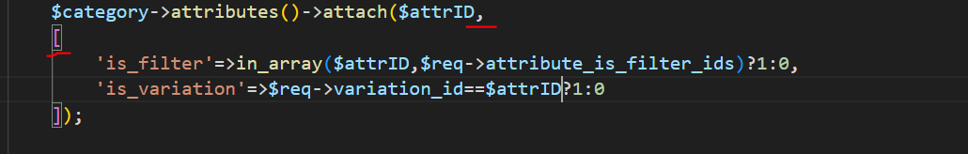

How to delete rows belog for a relation from an oring:

$categoy=Category::find(2);

 $category->attributes()->detach();

## Model class methods

1-a cool thing is that we can make a relation between one table, find children of a row:

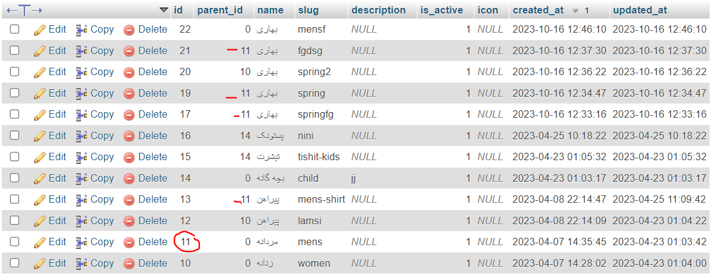

Logic: consider we have a category row and we want its children,we need to see which rows has its id as parent_id.

class Category extends Model

{

 public function parent()

    {

        return $this->belongsTo(Category::class, 'parent_id');

    }

    public function children(){

        return $this->hasMany(Category::class,'parent_id');

    }

}

As you can see origin and destination both are in category model class

#### whereHas and Has:

these are for when we have some collection of the orgin model but base of a model that are relation to orgin we filter and decress collectios

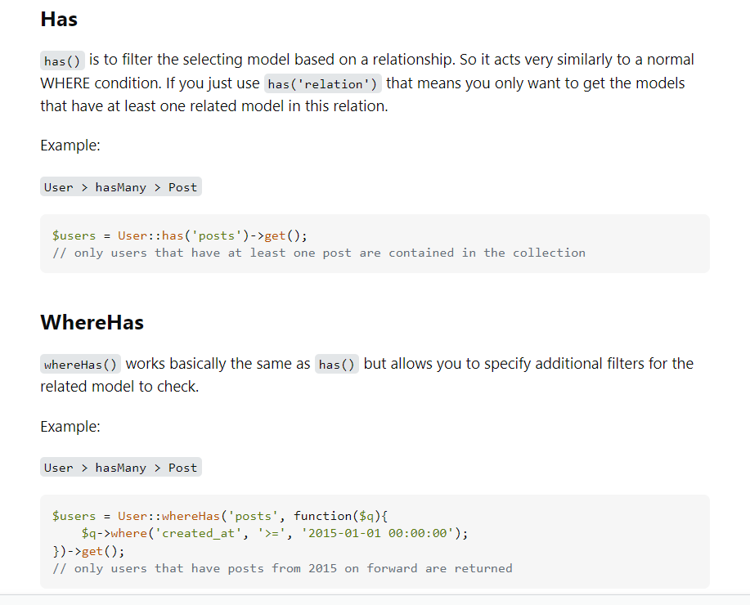

#### Use select method to distinct outcome:

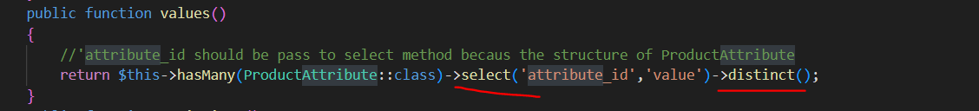

For distinct to happen we must to say in select method what $this has named in product_attributes table.

#### Accessor

1->Standard define name; 2->from title word value parameter refrence to title column;



Note: if we want to change the raw outcome of a coulme we pass the name of the coulmn as a variable like the example bellow:

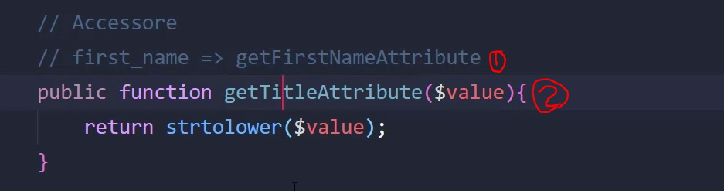

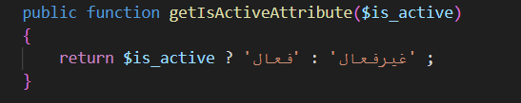

On view:

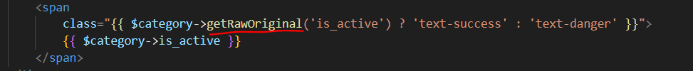

The accessor will change the original value of column,to discard accessor we can use getRawOriginal

#### **With method**

With methods receive a relation from to add it to a query that actualy going.



Loginc: 2 is a relation that exsists in model that refers in 1 relatoin.



Logic2:if we don’t use with method above code stil will work correctly the point is that with,with method after above code there is no more qurey to get the datas.

#### **wherePivote**:

bring me the attributes that are related to this category but first check the pivote table and bring only filterable attribute for this category.



# Validation

## Rules and syntax

Some usefull rulles and syntax:

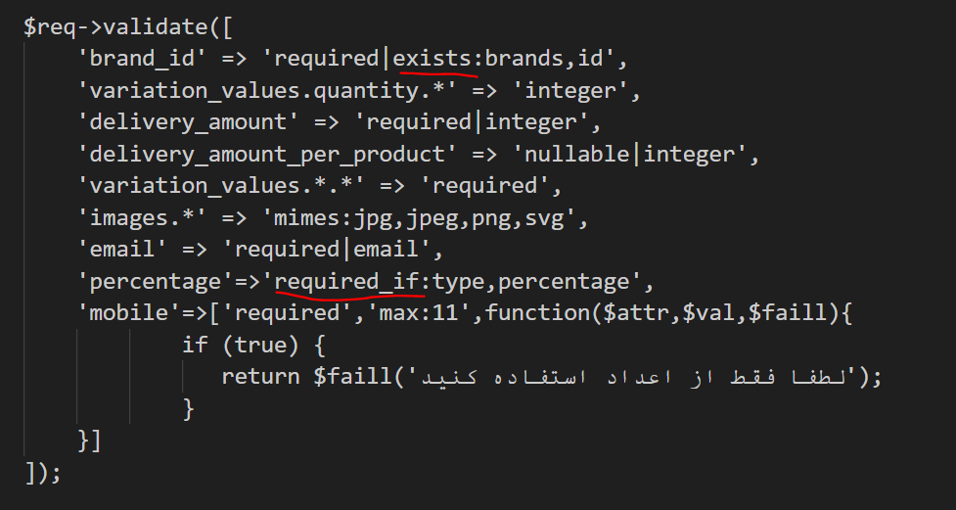

 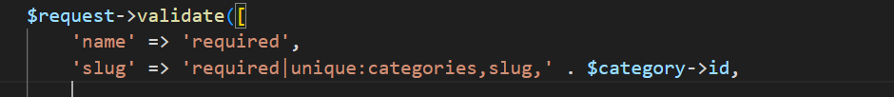

When we add an id as third parametr to unique it will discard that id on <<categories>>table

Its too usefull when we are updating tables.

## Withbag

Bags will define in backend and its only for error handling.

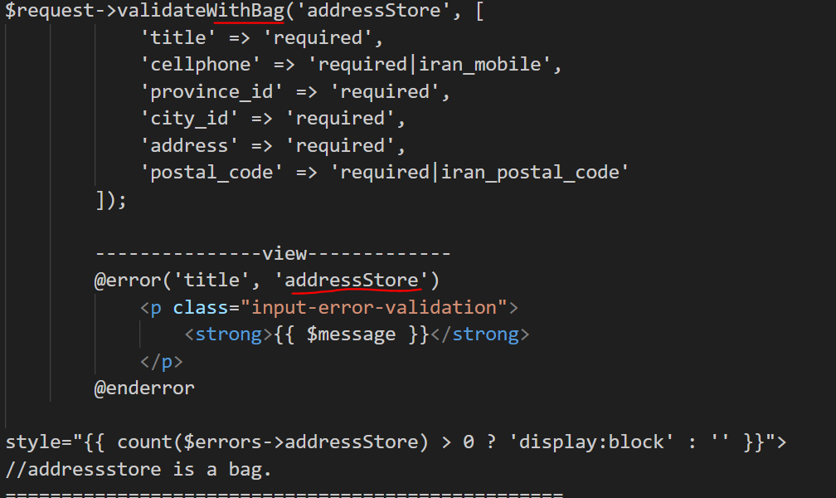

## Validator Façade

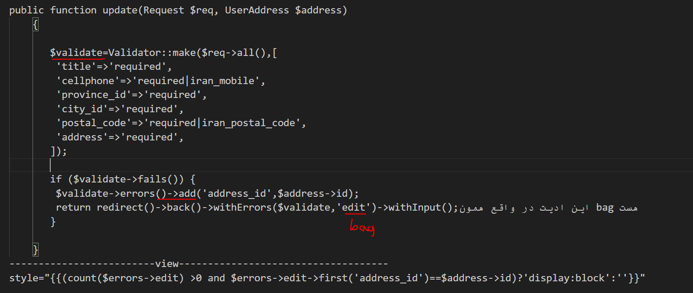

## On view

We can use a blade file and include this whenevey we want:

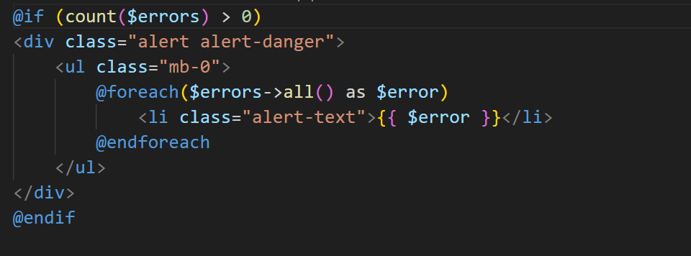

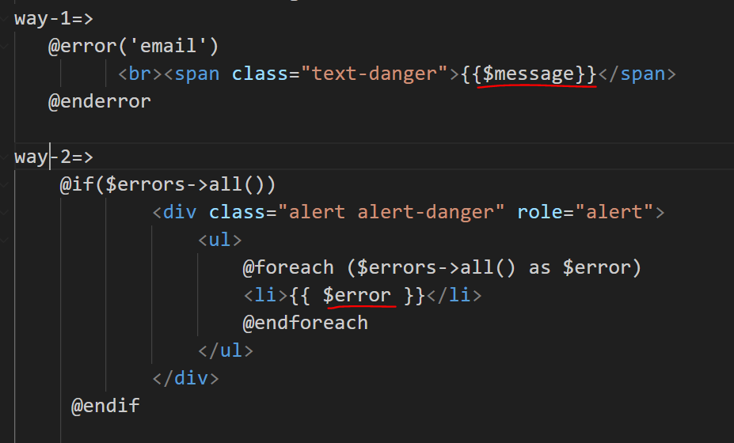

## Iran validation

<https://github.com/anetwork/validation>

# Pagination

### Instalation

We build a custom blade to be use as buttons for next and previous .then we will added to AppserviesPorvider:

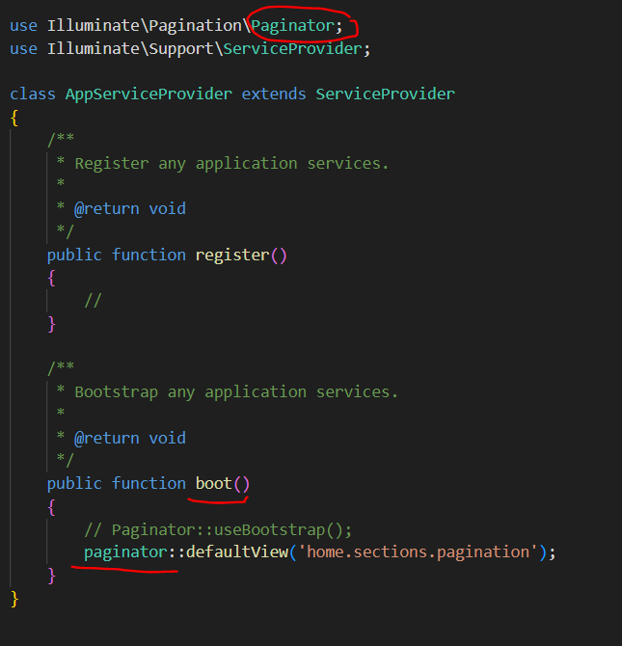

I have a sample of costom blade that style is based on bootstrap so the layout must had access to bootsrap library.

### Controller command

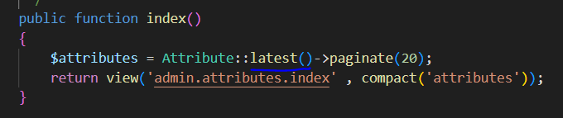

### On view

fefdefd

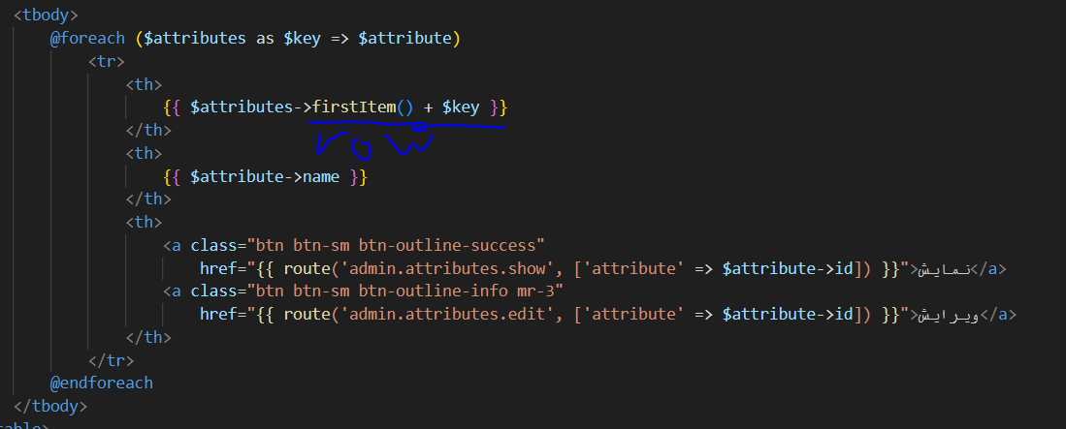

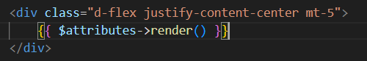

# How to program:

1-what is the target

2-what do we need/what is our parameters

3-bulid parameters

# Autentication:

## Auth helper function:

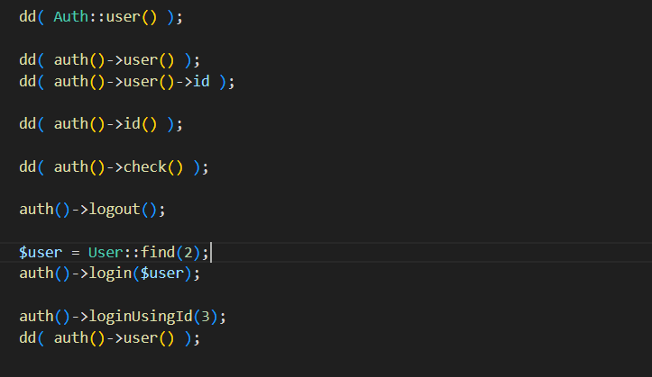

Second parameter:$remember=true

Is watcher of this page login?

## Normal via fortify:

-for normal authentication we use fortify that should be instal in project I suggest read the documentation.

-fortify only handle backend part of auth.

Instal and config:

1-

Composer require laravel/fortify

2-

php artisan vendor:publish --provider="Laravel\Fortify\FortifyServiceProvider"

This command will publish Fortify's actions to your app/Actions directory, which will be created if it does not exist. In addition, the FortifyServiceProvider, configuration file, and all necessary database migrations will be published.

3-

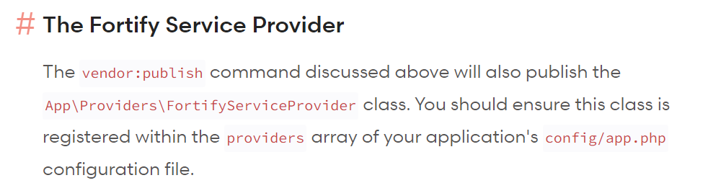

App\Providers\FortifyServiceProvider add this in config/app.php

Now we should check the features that we want, in fortyfy config file .with enabling the feature one of work that happen is to create related route.

### Registeration:

Introduce view:

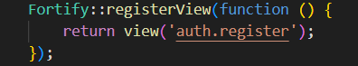

Form:

* Post endpiont(‘/register’)
* Name input
* Email/username input(in its config file we determine coulmn name that should check)
* Password input
* password_confirmation input
* if you have **more** **inputs** or you want **costomize** registeration go to App\Actions\Fortify\CreateNewUser

Where do we redirect after sucseed register: 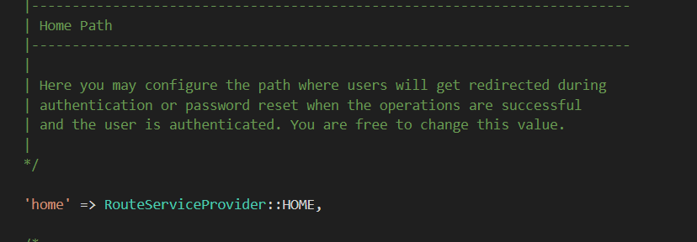

Or ‘/mydesire/url’

Config/forify.php

Config/forify.php

### Login:

View:

-In login to introduce view for url/login endpoint in forify service provider we add code bellow

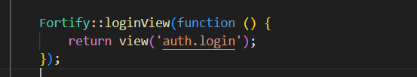

-it is not realy important to introduce a view for login the point is that we only need a form to contains our needed inputs to be able to work on it in backend,

Form:

* Endpoint :post to /login.
* Email/username input (in its config file we determine coulmn name that should check)
* Password input
* Remmeber input (must contain boolian)

Where do we redirect after sucseed login: 

Config/fortify.php

Or ‘/mydesire/url’

To customiz login credentials  reed documation.you can customize for redirect, go to documentation

## oAuth:

oAuth via google:

1- we must have a oauth acount in google console to get clinet id and client secret.

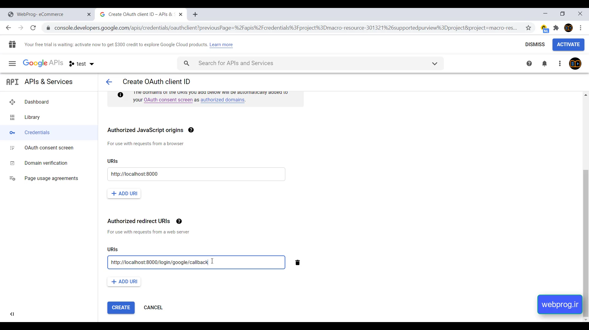

After console acount:

Laravel has a package called socialite for oAuth.

2- instal it by reading documentaion.

3- we need to create two route,one for sending request and socond for provider callback.



Give first route to related link buttons.for login or register both should go to this route and in backend we check if the user has already registerd or not.

4- we have to add our providers to config/services.php a example for google:

Tip-our redirect index should be equal with what wa write in google console.

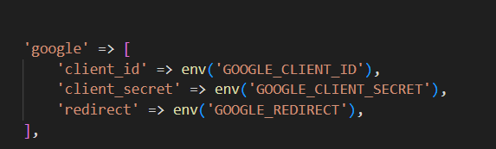

Serveces.php

5-redirect route : we just create the code bellow socialite do all the hard work

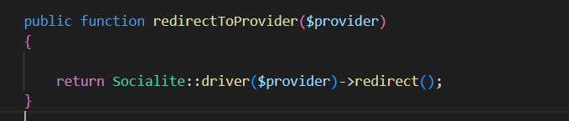

6- callback route:

First we get ansser of provider via socialite pakage.

I’m not sure why we using try and catch.

After that by user model we check the user existence and we proceed.

-socialite parameter call back work on all providers:

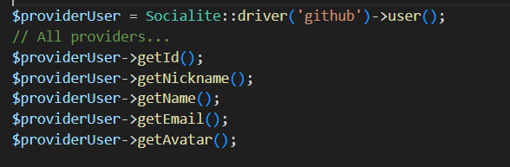

Tip: in bellow example attention to verfication email,password,remmember user.

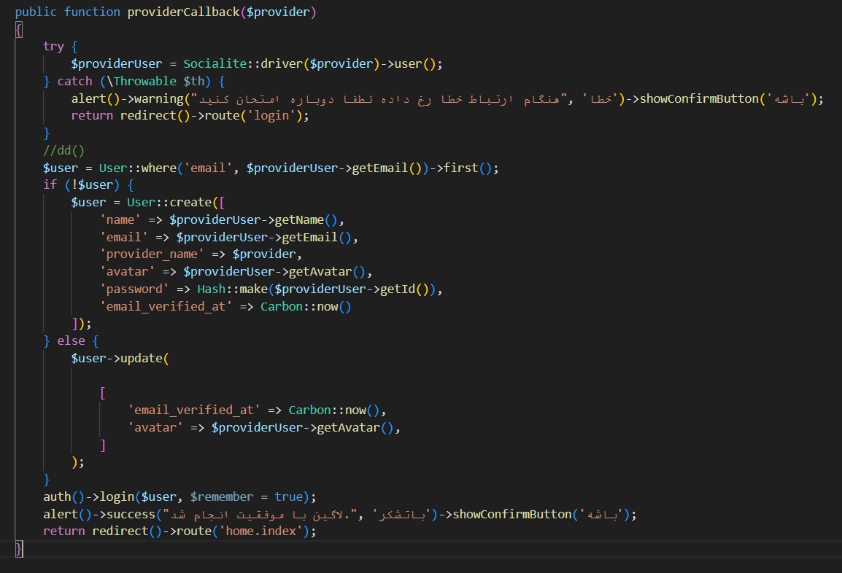



## Otp Autenticaton:

Login and register in otp is like oAuth,first we check that cellphone exisistence if cellphone is in table so we just update otp.

Gasedak sms service(episod 124)

path of picture bellow

1. We have a cellphone input and send it to server
2. We check the existece of cellphone if exist we update table and if not create
3. We make a random number via rand function base the digit we want(otp)
4. We need a uniqe random string(Hash::make) to place it in table to act as our id,(login_token is a proper name)
5. Now we do table part(create for first time and update for more than one)
6. Sms otp to user
7. We need a form for user to place otp in it and we check theotp correction by the login_token column
8. And after that we do login.

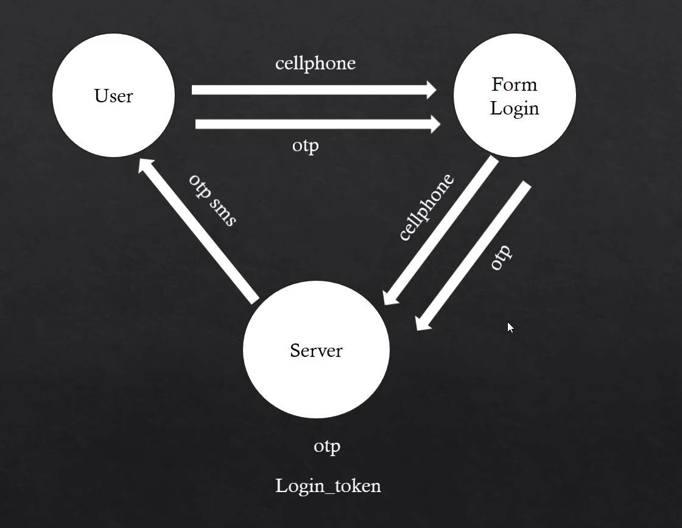

3

2

3

1

# Notification:

sending parameter? in our notification, is via notification constructor:

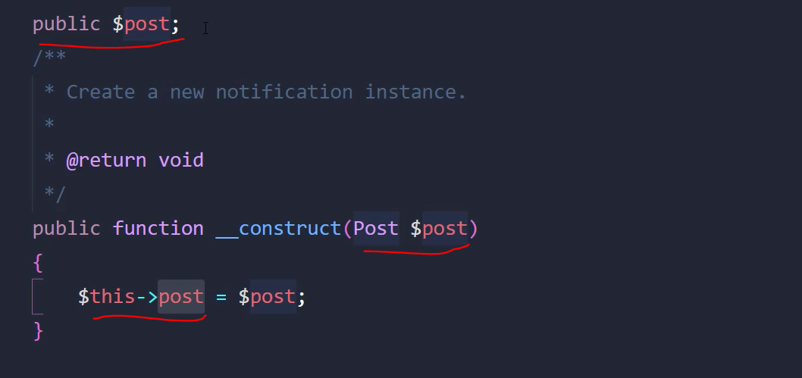

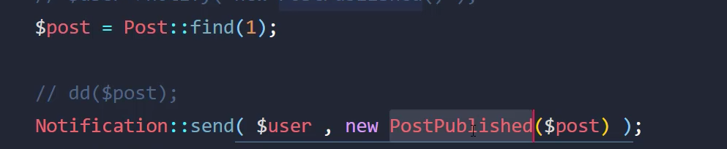

## Via Email:

First we need to cofiger mail class of laravel because notificaton use that.

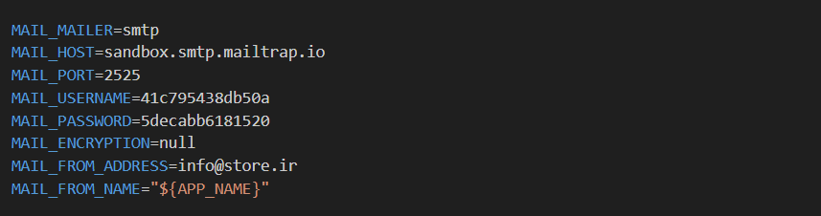

Second: we make a notification via artisan.

How to use preview laravel mail when using notification?

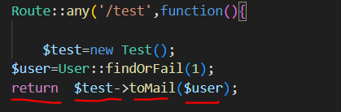

Notification setup:

Tip-After thinking I rather to use way 1 for sending email,

customize words? of MailMassage of laravel run code bellow:

php artisan vendor:publish --tag=laravel-notifications

how to customize css?

Run code bellow:it wil make resources/views/vendor/mail and in it find default.css and palce your style.

php artisan vendor:publish --tag=laravel-mail

Tip-$notifable in bellow is an object of user model so we can use its index.

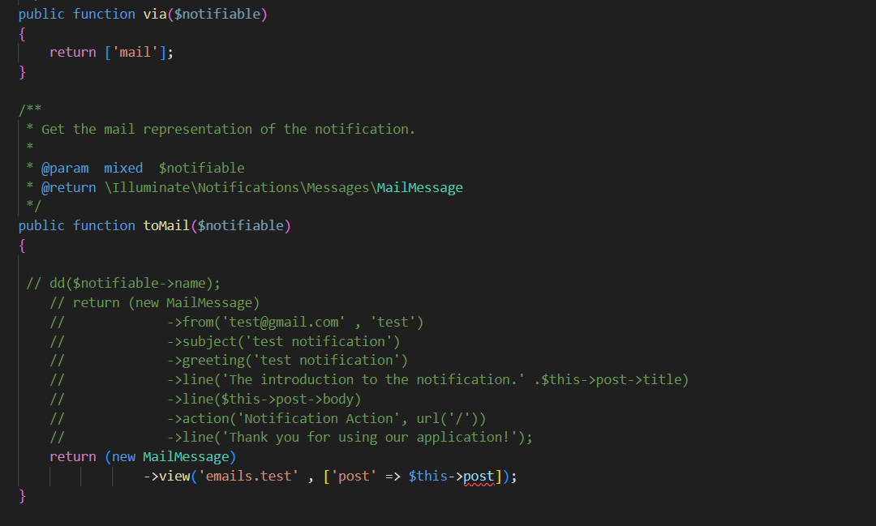



How we send a notification?

User model has a trait in it as notifable because of that we can do this:

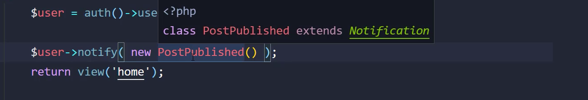

We are in a controller

Or we can do it via notificaton façade:



Tip-if we have more than one user to send email just set a collection of users in parameter one.

## Via sms:

1-we need a sms channel so we create a channels directory in app directory:

In sms channel we need a

1)send method with tow parameter first a user and second our built notification

2)a web serviec to send the massage (qasedack has a good doucmentaion)

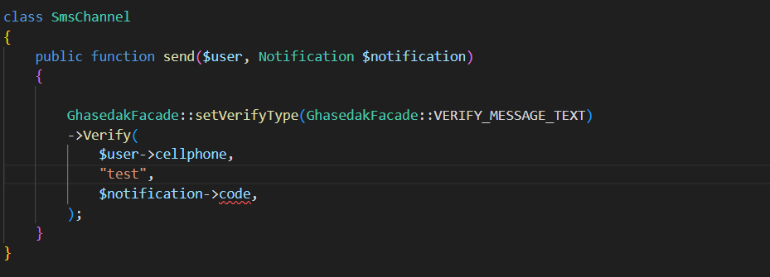

2-create a notification for it. And do bellow setups:

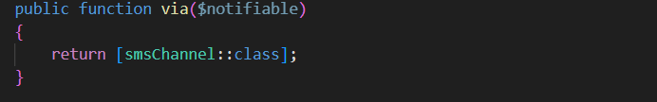

OtpSms-notification

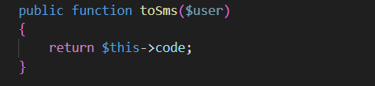

OtpSms-notification

# Localization:

There is simples in assets.

We should change language in config/app.php

## Verify email and reset password:

The statements of this notification are in the pass bellow and as they are in lang function we can localize it easly

Vender/laravel/framefork/src/auth/notifications.

1-chcek the above path for statements

2-place and translate statements in fa.json in rescoures/lang

There is simples in assets.

# Documentation and other

## Hashing:

Just go for documentation I’m not in mood.

## Session

How to add to an existing array session?



Caution for the first time we should:



Delete from a array?

